**Design “Class” Diagram**

*<Summary of each part of the* [*design class diagram*](https://miro.com/app/board/uXjVPCcM4ig=/)*, if it is decomposed into several parts>*  
 [*https://miro.com/app/board/uXjVNRbr2A0=/?share_link_id=574326552583*](https://miro.com/app/board/uXjVNRbr2A0=/?share_link_id=574326552583)

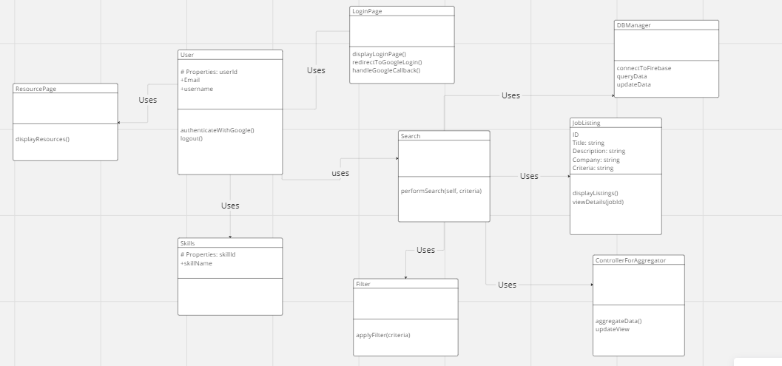

*The design diagram above shows how our app functions. The classes shown have their methods included for how they function. Search class being the one that will primarily communicate with the firebase server and aggregator to find the job listings. Users will be able to login by using google authentication, making it easier for us to store user information in the firebase server. Search class will use the Filter class if the user chooses to in order to have a better fit to their choice of job. JobListings are listed appropriately with job title, job description, and way to apply. A recourse page can be accessed by the user that has a list of interview tips and advice for job security.*

**Design Patterns**

**Name of design pattern e.g. Facade**

*From my findings of the design patterns, we find that our app follows a Front Design pattern as shown below in a sub diagram. The diagram gives a more simplified view of the app. Since the app is an aggregator, this makes it so we really just need a controller that interacts with the database to retrieve and send data. Thus why all the initial methods are listed under the controller.*

[*https://miro.com/app/board/uXjVNRbr2A0=/*](https://miro.com/app/board/uXjVNRbr2A0=/)

